|  |  |  |
| --- | --- | --- |
| **University of Petra** | شعار جامعة البترا5 - |  |
| **Faculty of Information Technology** | **كلية تكنولوجيا المعلومات** |

**Software Engineering Project**

**Learning Management System**

**Prepared By:**

**Leen Arnous - 202110657**

**Ahmad Aldweik - 202110034**

**Sarah shawawreh - 202110317**

**Nawras Abunassr - 202110637**

**Nagham Alotaibi - 202110560**

**Supervisor:**

**Prof Nuha El-Khalili**

**Date:**

**2024/2025**

**Introduction**

The purpose of this document is to collect, analyze, and define high-level needs and features of the Learning Management System (LMS). The LMS is a software that manages, tracks, and delivers educational or training programs. It serves as a central location for the faculty to produce and administer course content, while students may access resources, interact, and track their progress. Key features include course management, user management, content storage and sharing, communication tools, evaluation capabilities, reporting, and customization choices. LMS platforms are essential for organizing learning in a variety of settings, from schools to organizations, and provide effective online or blended learning experiences.

**Problem Statement**

* There are many platforms in the university such as Teams, Moodle, and Registration System.
* The current system depends on outsiders for some purposes.
* According to quality assurance, there are many reports that cannot be taken from the current systems.

**Project Objectives**

* One platform will have multiple features, like a registration system, quality assurance, and the ability to add any type of files like word documents, PowerPoint presentations, and pdf files.
* A special system should be implemented to not depend on third party organizations and to be able to control adding the things we need with no help from people from outside.
* The system will include a service of withdrawing the list of students from the registration system on the new system of students registered for the course they need.
* The system will include assignment management for students.
* The system will include grades management.
* The new system is entirely within the university and the e-learning center is fully responsible for it.
* Students must take files, add assignments, and interact with each other.
* A website and mobile application will be developed for the new learning management system.
* Security must be strong, and the system must handle many users.
* There must be a backup copy periodically.
* There must be tracking for student activity.
* A suite of reports must analyze everything, including student and faculty achievement and feedback.
* The students can use Chatbot to ask questions, gain information, and take advice.

**Effects of the Project**

1. **Environmental effect:**

There is a positive impact that the LMS has on the environment by avoiding paper, conducting all transactions electronically, and burning less gasoline and diesel fuel used for transportation to and from the university.

1. **Economic effect:**

The financial savings come from not needing to print and distribute advertisements, as well as reducing transportation expenses, also saving time and effort.

1. **Educational effect:**

Its educational impact facilitates learning by implementing asynchronous activities and online learning, and communication between the student and the faculty.

1. **Social effect:**

The LMS fosters collaboration, engagement, diverse learning support, feedback among students and faculty.

1. **Commercial effects:**

The LMS brings cost savings, scalability, revenue opportunities, efficiency, competitive advantage, and compliance management.

1. **Security effects:**

Security measures are taken to ensure that sensitive and confidential information, like student grades and financial records, can only be accessed by members who have authorization.

All records are continuously backed-up by the system, to ensure that they are protected from any future malfunctions.

**Stakeholder List**

|  |  |  |  |
| --- | --- | --- | --- |
| **Stakeholders** | **Description** | **Interest** | **Importance** |
| **Student** | Student of University of Petra | Viewing course information and financial records | High |
| **General Administration** | Administration staff of the university | Helping in student registeration | High |
| **President of the University** | The leader of the university | Sharing updates about the university that involves the students and the staff | Low |
| **Higher Education** | The Ministry of Education in Jordan | Implementing the standards of education in the country | Low |
| **College Deans** | The heads of the colleges | Sharing important announcements that benefit students academically | Medium |
| **University Professors** | Academic leaders who teach the university courses | Handling course grades, online recources, attendence, and exams | High |
| **Quality Assurance** | The team that checks the quality of the system | Ensuring that the LMS provides a reliable, user-friendly, and secure environment and that the stakeholders' requirements are met | High |
| **E-learning and**  **IT support staff** | The team that provides technical support for asynchronous activities and online learning, as well as the system in general | Ensuring smooth operations, providing security, troubleshooting issues, performing system maintenance, and implementing updates or upgrades regarding the LMS | High |

**Proposed Scope and Process Model**

We will use the Unified Process Model to be able to gain rapid feedback from users and developers, see visible progress, and manage the complexity of the project efficiently, starting with high risks. Firstly, we will start by extracting requirements to understand the needs of the university system. We will then proceed to design, develop, and deliver a new website and mobile application on their own server. This platform will allow students to access all past and current courses, enabling them and the faculty to upload different types of files, including images and videos, as well as the ability to convert files, while supporting deletion, timestamp proof, and notifications for anything uploaded by a professor. In addition, the system will be able to provide the user with any community services, events held at the university, or training courses so that the user can view them directly. The system will include a meeting feature with audio and camera functions, in addition to a chat feature for both the students and the faculty, with the possibility of integrating a chatbot and registration system. Regular backups will be performed, approximately weekly, with reports delivered to analyze student data. The system will provide the professor with the ability to add new courses, and the university will be responsible for managing them.

**Scope Excluded and Project Constraints**

The integration with the university registration system, including student information, will not be implemented within the project's timeframe due to security concerns and time limitations.

**Scope Initiation (WBS)**

|  |  |  |
| --- | --- | --- |
| **Tasks** | **Dependency** | **Duration** |
| **1 - Inception** |  | 17 weeks |
| **1.1 - Define project goals and scope** |  | 2 weeks |
| **1.2 - Gather initial requirements from stakeholders** | 1.1 | 2 weeks |
| **1.3 - Create project charter** | 1.2 | 1 week |
| **1.4 - Gather specific languages requirements** | 1.3 | 1 week |
| **1.5 - Initial security risk and planning** | 1.4 | 2 weeks |
| **1.6 - Define functional specification** | 1.5 | 2 weeks |
| **1.7 - Identify technical and security requirements** | 1.6 | 2 weeks |
| **1.8 - User interface design for website in Arabic** | 1.7 | 1 week |
| **1.9 - User interface design for website in English** | 1.7 | 1 week |
| **1.10 - User interface design for mobile app in Arabic** | 1.8 | 2 weeks |
| **1.11 - User interface design for mobile app in English** | 1.9 | 2 weeks |
|  |  |  |
| **2 - Elaboration** | 1 | 52 weeks |
| **2.1 - Frontend development for website in Arabic** | 1 | 6 weeks |
| **2.2 - Frontend development for website in English** | 1 | 6 weeks |
| **2.3 - Frontend development for mobile app in Arabic** | 2.1 | 8 weeks |
| **2.4 - Frontend development for mobile app in English** | 2.2 | 8 weeks |
| **2.5 - Backend development with security features implementation** | 2.4 | 14 weeks |
| **2.6 - Database implementation** | 2.5 | 8 weeks |
| **2.7 - Security testing** | 2.6 | 10 weeks |
| **2.8 - User acceptance testing for websites** | 2.7 | 8 weeks |
| **2.9 - User acceptance testing for mobile app** | 2.7 | 8 weeks |
|  |  |  |
| **3 - Constructions** | 2 | 29 weeks |
| **3.1 - System deployment** | 2 | 4 weeks |
| **3.2 - Data migration** | 3.1 | 4 weeks |
| **3.3 - User training** | 3.2 | 4 weeks |
| **3.4 - Documation development** | 3.3 | 2 weeks |
| **3.5 - Bug fix** | 3.4 | 4 weeks |
| **3.6 - Provide ongoing security** | 3.4 | 2 weeks |
| **3.7 - Implement feedback mechanisms** | 3.6 | 4 weeks |
| **3.8 - Updates and enhancements** | 3.7 | 8 weeks |
|  |  |  |
| **4 - Transition** | 3 | 6 weeks |
| **4.1 - Provide ongoing security monitoring** | 3 | 6 w |
| **4.2 - Ensure feedback mechanism are monitoring** | 3 | 6 w |
| **4.3 - Technical support** | 3 | 6 w |

**Gantt Chart**

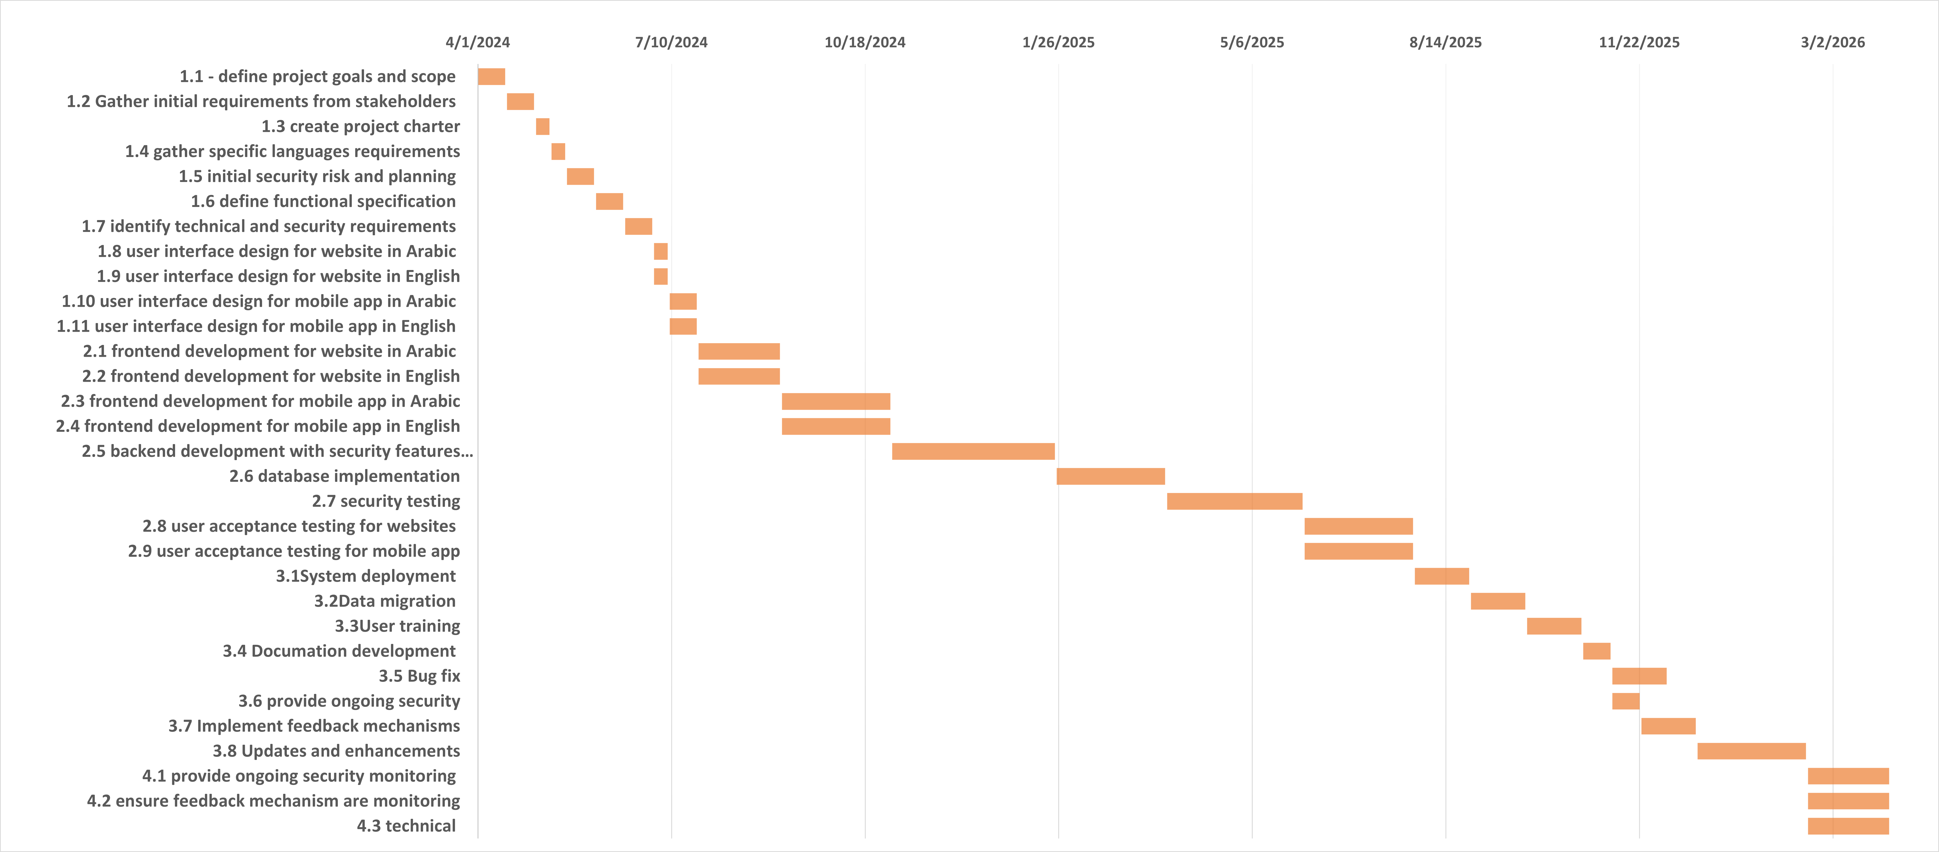

**Cost Estimating and Budgeting**

|  |  |  |
| --- | --- | --- |
| **Cost (in JOD)** | **Component** | **Categories** |
| **2000**  **1000**  **1500**  **1000** | **Server Infrastructure**  **Networking Equipment**  **Backup Systems**  **System Management Hardware** | **HW needed** |
| **1000**  **1500**  **500** | **software licenses**  **development tools**  **third-party software required** | **SW needed** |
| **13000**  **10500**  **9000**  **9000** | **Project Manager**  **Developer**  **Designer**  **Tester** | **People and Estimation of Salary** |
| **50000** | **-** | **Total calculated** |

**Risk List**

Here are some challenges and risks that we might encounter during the process of building this system:

1. **Technology Advancements:** Rapid advancements in technology may render certain software or hardware components outdated, requiring frequent updates or redesigns.
2. **Changes in Requirements:** Additional features or changes in requirements during development may extend the project timeline and strain resources.
3. **Resource Constraints:** Limited availability of skilled developers and instructional designers could slow down development.
4. **Scope Misalignment:** Misalignment between stakeholders' expectations and project scope may result in feature creep, project delays, or budget overruns.
5. **Technical Compatibility:** Ensuring compatibility across various devices and browsers for a diverse user base may pose a challenge.
6. **Estimating costs:** It can be difficult to estimate costs accurately and care must be taken to manage the budget effectively.

**Product Features**

Here is a list of the most important product features:

1. **Course Management:** The system shall allow instructors to create, organize, and manage courses, including uploading course materials, setting assignments, and grading.
2. **Student Management:** The system shall provide tools for administrators to enroll students, track their progress, and manage user accounts.
3. **Assessment and Grading:** The system shall implement features for creating quizzes, assignments, and exams, with options for automated grading and feedback.
4. **Discussion Forums:** The system shall enable communication and collaboration among students and instructors through discussion forums and messaging.
5. **Content Repository:** The system shall offer a centralized repository for storing and sharing course materials, videos, documents, etc.
6. **Progress Tracking:** The system shall provide dashboards and reports for students and instructors to track progress, completion rates, and performance.
7. **Mobile Learning:** The system shall ensure the platform is mobile-responsive, allowing students to access course materials and participate in activities on smartphones and tablets.
8. **Chatbot Usage:** The system shall provide a Chatbot for students to ask questions, gain information, and take advice.

**Non-functional Requirements:**

1. **Reliability:** The system should be reliable and available at all times, especially during peak usage periods like exams or assignment deadlines, to support uninterrupted learning activities.
2. **Scalability:** The system should be scalable to accommodate growing user bases and increasing course loads without sacrificing performance.
3. **Usability:** The system should provide an intuitive and user-friendly interface with clear navigation and consistent design to enhance user experience and engagement.
4. **Security:** The system should implement robust security measures to protect user data, prevent unauthorized access, and comply with data protection regulations.
5. **Accessibility:** The system should meet accessibility standards, allowing all users, including those with disabilities, to access and interact with the content.
6. **Multilingual Support:** The system should support multiple languages to accommodate diverse user populations, allowing for localization of content and user interface elements.
7. **Support and Maintenance:** The system should have a dedicated support team and established maintenance procedures to address user inquiries, resolve technical issues, and apply updates and patches to ensure ongoing system functionality and security.
8. **Performance:** The system should maintain optimal performance levels, ensuring fast loading times for content and minimal latency during live interactions such as video conferencing and chat sessions.
9. **Compatibility:** The system should be compatible with a variety of devices and operating systems to accommodate users accessing the platform from different devices such as desktops, laptops, tablets, and smartphones.
10. **Performance Monitoring:** The system should include monitoring tools to track system performance metrics such as server uptime, response times, and user activity patterns, allowing for proactive maintenance and optimization.